You can get daily updates, by email, showing all Planning applications in your area, by registering on the Ealing Planning portal. Just follow the instructions below and then you‘ll get a daily email showing all new and changed applications within your selected area!

Step 1 – Register an account on the Ealing Planning portal

Go to the following web site: pam.ealing.gov
And click on “Register”
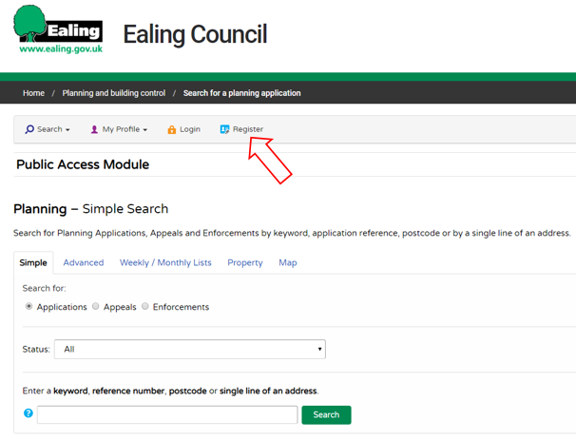

Complete the Registration form with your details, select a password (make sure it has a mixture of letters and numbers) and click “next”
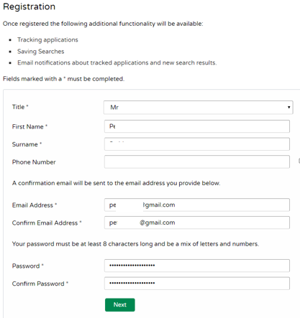

Enter your postcode and click “next”
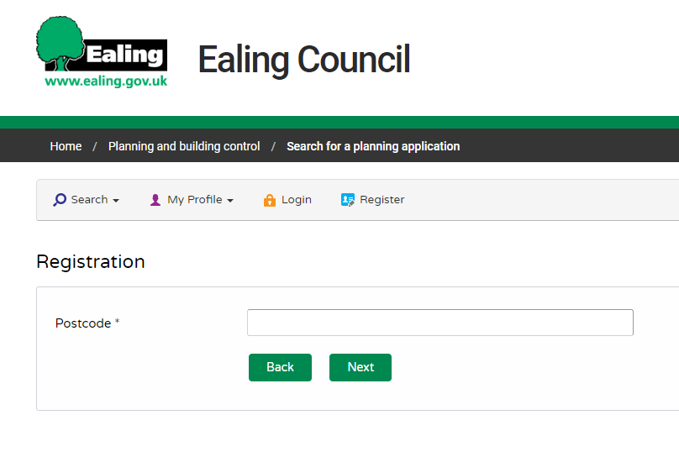

Select you address from the list and click “next”
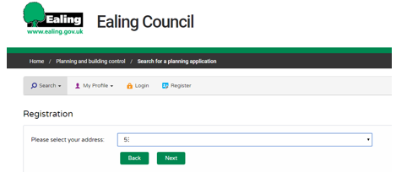

Confirm you agreement and click next
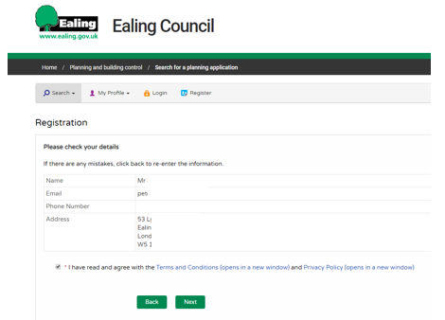

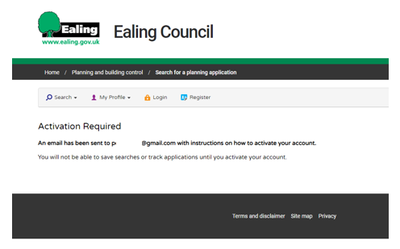
You will get a message like this:

Now go to your email and open the email and click on the link to activate your account.
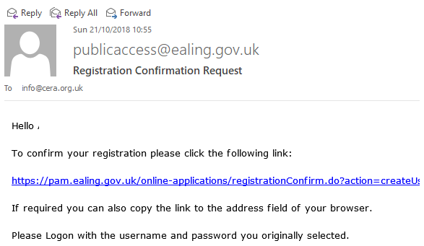

Your account is now created.

Step 2 – Configure your account to receive updates on Planning applications
Click on “Login”
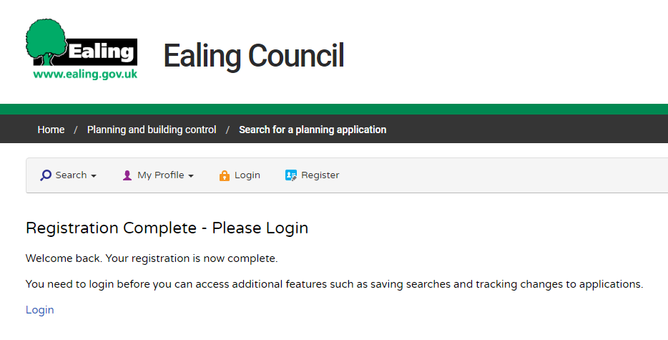

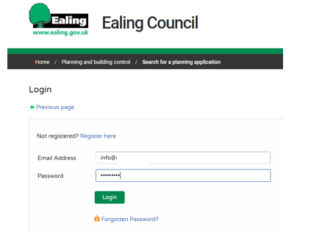
Enter your email address and password

Click on Search, Planning, Advanced:

Select the area you want updates on. Eg if you want updates on all applications a specific road, enter that road name in the “Address” field, or if you want updates on all applications in a specific Ward, select that Ward in the “Ward” field.
Then click “Search”.
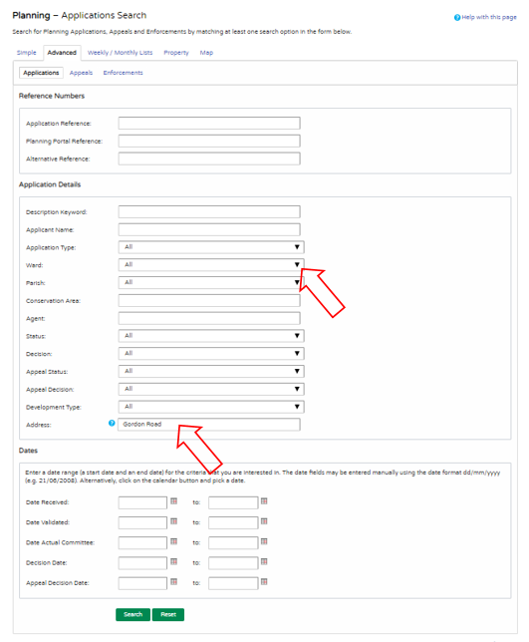

A list of Planning Applications for the selected criteria will now be displayed. To receive updates by email on similar applications in the future, click on “Save search”
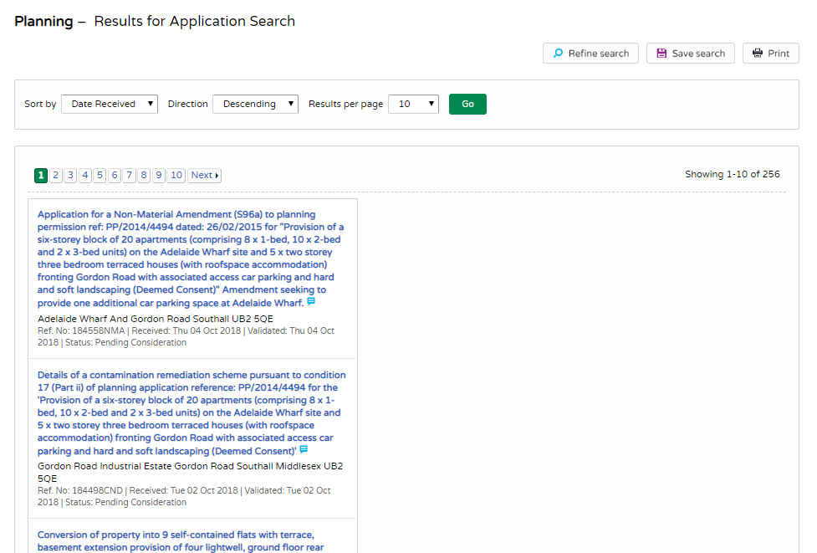

You can now modify the title of your search.
Click on “Yes” by “notify me via email about new search results”
Click on “Save”
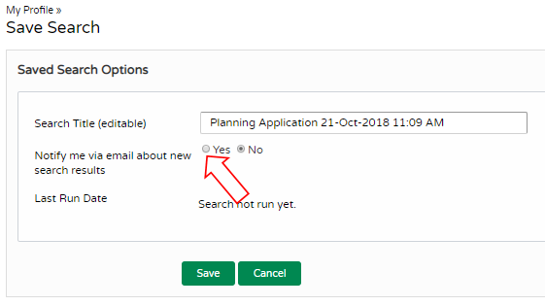

Your search is now saved. You can register additional searches. For example you can search for Planning Applications on another street, or possibly to track progress of a specific application. You can also search and save licencing applications.

Once you have completed your searches click on “Logout”.
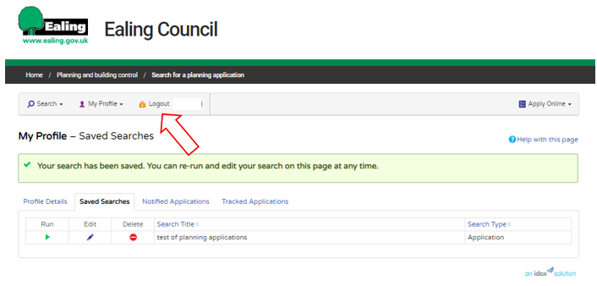

You can make changes to your saved searches at any time in the future, by logging in to your account using your registered email and password.

